***A Classical Music Evening***

**Bytown Trio**



**Anna Baksheeva, violin**

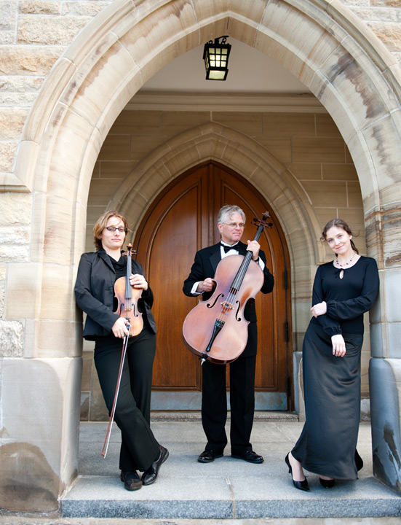

**Jan Jarvlepp, cello**

**Ioulia Blinova, piano**

**Trios by**

**Beethoven, Sibelius, Mendelssohn**

**Friday, June 24 at 7:30 p.m.**

*St. Thomas the Apostle Anglican Church*

***2345 Alta Vista Drive (at Randall Ave., OC Transpo: Route No. 8)***

**Admission by Donation**